Name: __________________ phone: ___________________email: __________________
Gildan SoftStyle Hoodie DESIGN A $35 | Gildan Softstyle Short Sleeve DESIGN A $20
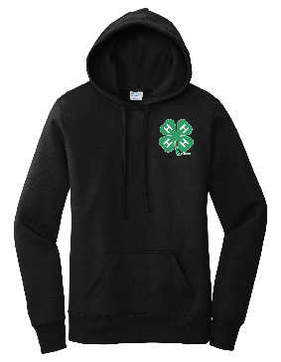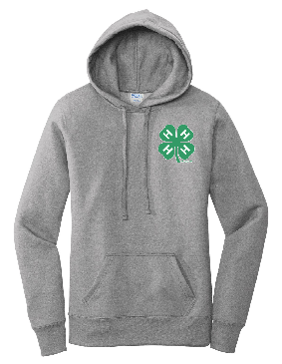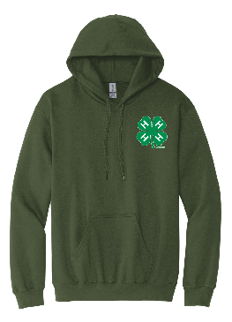 | 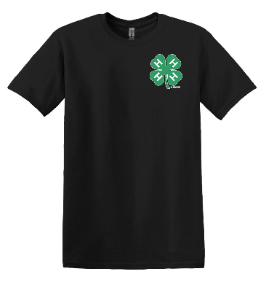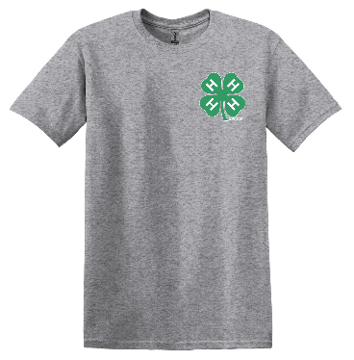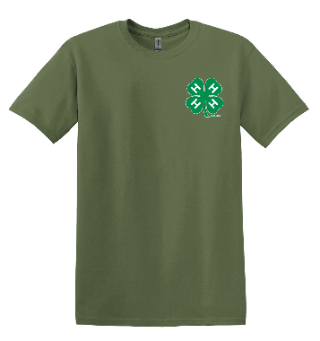
Gildan SoftStyle Hoodie DESIGN B $35 | Gildan Softstyle Short Sleeve DESIGN B $20
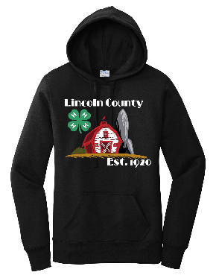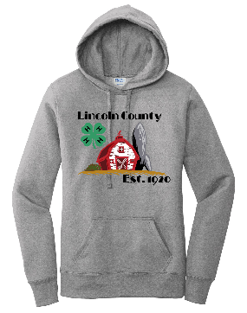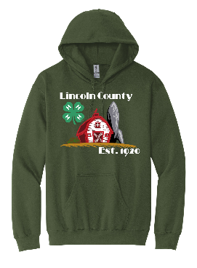 | 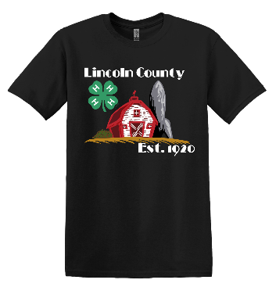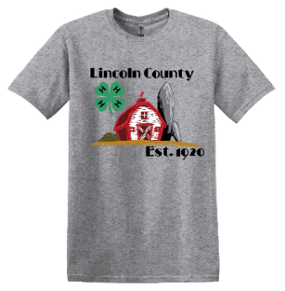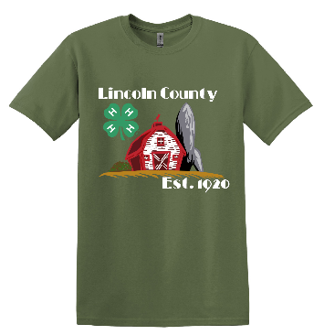
Embroidered Polo $24 | Sublimated Hoodie $35
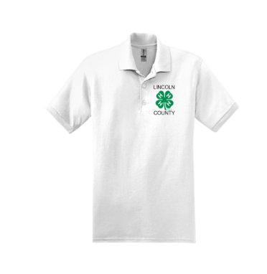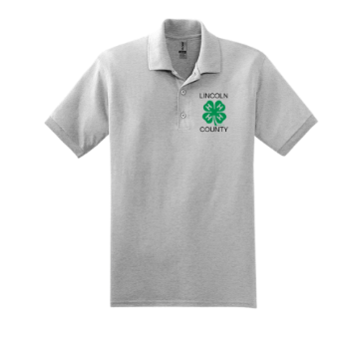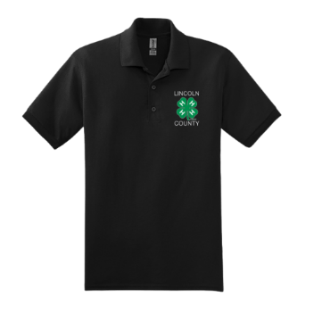 | 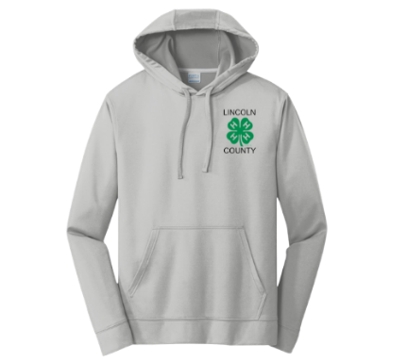
 | Youth Small | Youth Medium | Youth Large | Adult  Small | Adult Medium | Adult Large | Adult  X Large | Adult  XX Large | Adult  XXX Large | Total
HOODIES AND TEES NOTE DESIGN CHOICE – A or B and QUANITY |  |  | A 1 |  | B1
Light Gray Hoodie |  |  |  |  |  |  |  |  |  | $
Black Hoodie |  |  |  |  |  |  |  |  |  | $
Military Green Hoodie |  |  |  |  |  |  |  |  |  | $
Light Gray Short Sleeve Tee |  |  |  |  |  |  |  |  |  | $
Black Short Sleeve Tee |  |  |  |  |  |  |  |  |  | $
Military Green Short Sleeve Tee |  |  |  |  |  |  |  |  |  | $
Sublimated Light Gray Hoodie |  |  |  |  |  |  |  |  |  | $
White Polo Tee |  |  |  |  |  |  |  |  |  | $
Gray Polo Tee |  |  |  |  |  |  |  |  |  | $
Black Polo Tee |  |  |  |  |  |  |  |  |  | $

GrandTotal:_________________
Orders Due By: Please make checks Payable to Simply Stitched

Order online at https://simply-stitched-llc.myshopify.com/collections/lincoln-county-4-h
- Apparel Fundraiser – Lincoln County 4H
- Select Shipping at check out and then choose Delivery. Online orders will be delivered to Lori Lashua for distribution.

